Frame Relay

🧱 What Is Frame Relay?
# Source: AI Source: Provided by: [Data Path: Persons Table -> ID Column: 1, Name_En Column: Motasem Essam] -> From: [ChatGPT] on [1/16/2026]
Frame Relay is a WAN (Wide Area Network) protocol that operates at OSI Layer 2 (Data Link Layer). It is used to transmit data between geographically distant LANs over virtual circuits provided by a telecommunications carrier.
Originally designed for efficient and fast packet-switching, Frame Relay became popular in the 1990s for connecting branch offices and enterprise sites before technologies like MPLS, VPN, and broadband became common.

🧠 Simple Definition:
# Source: AI Source: Provided by: [Data Path: Persons Table -> ID Column: 1, Name_En Column: Motasem Essam] -> From: [ChatGPT] on [1/16/2026]
Frame Relay is a fast, low-overhead WAN protocol that sends variable-length frames over a virtual circuit between two locations — ideal for interconnecting remote LANs over long distances.

🔧 How Frame Relay Works
# Source: AI Source: Provided by: [Data Path: Persons Table -> ID Column: 1, Name_En Column: Motasem Essam] -> From: [ChatGPT] on [1/16/2026]
- Uses virtual circuits:
  - PVC (Permanent Virtual Circuit) – always available
  - SVC (Switched Virtual Circuit) – temporary
- Transmits data as frames — each frame contains addressing and control info to reach the correct destination.
- Connection-oriented but doesn’t guarantee delivery (no error correction).

📦 Frame Relay Frame Format
# Source: AI Source: Provided by: [Data Path: Persons Table -> ID Column: 1, Name_En Column: Motasem Essam] -> From: [ChatGPT] on [1/16/2026]
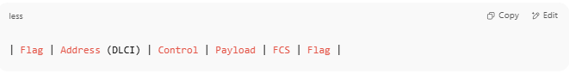| Flag | Address (DLCI) | Control | Payload | FCS | Flag |

🔍 Frame Field Breakdown
# Source: AI Source: Provided by: [Data Path: Persons Table -> ID Column: 1, Name_En Column: Motasem Essam] -> From: [ChatGPT] on [1/16/2026]
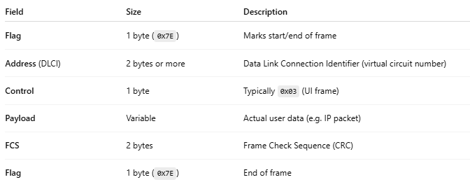

Field | Size | Description
Flag | 1 byte (0x7E) | Marks start/end of frame
Address (DLCI) | 2 bytes or more | Data Link Connection Identifier (virtual circuit number)
Control | 1 byte | Typically 0x03 (UI frame)
Payload | Variable | Actual user data (e.g. IP packet)
FCS | 2 bytes | Frame Check Sequence (CRC)
Flag | 1 byte (0x7E) | End of frame

🧠 Visual Example – Frame Relay Frame (Simplified)
# Source: AI Source: Provided by: [Data Path: Persons Table -> ID Column: 1, Name_En Column: Motasem Essam] -> From: [ChatGPT] on [1/16/2026]
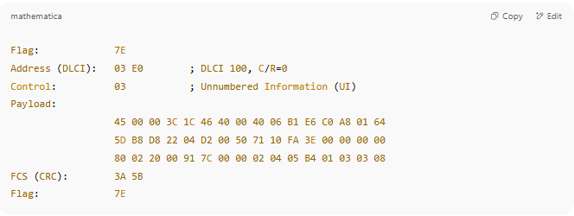

Flag: 7E
Address (DLCI): 03 E0 ; DLCI 100, C/R=0
Control: 03 ; Unnumbered Information (UI)
Payload:
45 00 00 3C 1C 46 40 00 40 06 B1 E6 C0 A8 01 64
5D B8 D8 22 04 D2 00 50 71 10 FA 3E 00 00 00 00
80 02 20 00 91 7C 00 00 02 04 05 B4 01 03 03 08
FCS (CRC): 3A 5B
Flag: 7E

✅ Key Characteristics
# Source: AI Source: Provided by: [Data Path: Persons Table -> ID Column: 1, Name_En Column: Motasem Essam] -> From: [ChatGPT] on [1/16/2026]
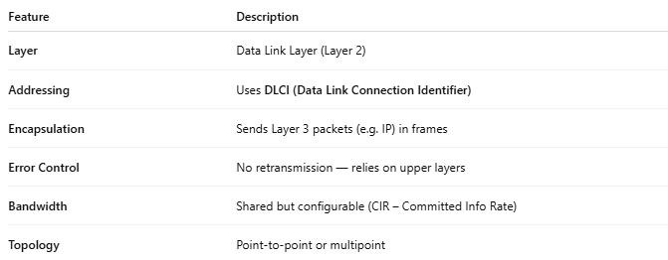

Feature | Description
Layer | Data Link Layer (Layer 2)
Addressing | Uses DLCI (Data Link Connection Identifier)
Encapsulation | Sends Layer 3 packets (e.g. IP) in frames
Error Control | No retransmission — relies on upper layers
Bandwidth | Shared but configurable (CIR – Committed Info Rate)
Topology | Point-to-point or multipoint

🆚 Frame Relay vs Other WAN Techs
# Source: AI Source: Provided by: [Data Path: Persons Table -> ID Column: 1, Name_En Column: Motasem Essam] -> From: [ChatGPT] on [1/16/2026]
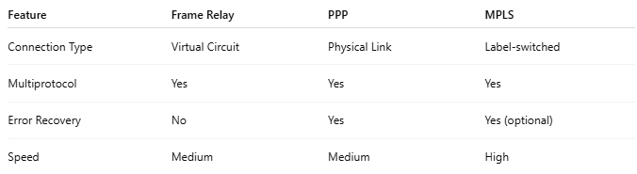

Feature | Frame Relay | PPP | MPLS
Connection Type | Virtual Circuit | Physical Link | Label-switched
Multiprotocol | Yes | Yes | Yes
Error Recovery | No | Yes | Yes (optional)
Speed | Medium | Medium | High

🔄 Typical Use Case
# Source: AI Source: Provided by: [Data Path: Persons Table -> ID Column: 1, Name_En Column: Motasem Essam] -> From: [ChatGPT] on [1/16/2026]
- Connecting remote branch offices to a central data center
- Carried over leased lines or telco networks
- Often replaced today by VPN, SD-WAN, or MPLS

🧾 Summary
# Source: AI Source: Provided by: [Data Path: Persons Table -> ID Column: 1, Name_En Column: Motasem Essam] -> From: [ChatGPT] on [1/16/2026]
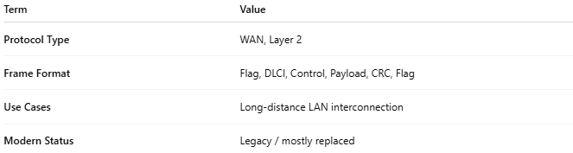

Term | Value
Protocol Type | WAN, Layer 2
Frame Format | Flag, DLCI, Control, Payload, CRC, Flag
Use Cases | Long-distance LAN interconnection
Modern Status | Legacy / mostly replaced

